SIMATS ENGINEERING
SAVEETHA INSTITUTE OF MEDICAL AND TECHNICAL SCIENCES
CHENNAI – 602105
Department of Computer Science and Engineering

ASSESSMENT TOOL 1 – CASE STUDY

Course Code: | DSA0502 | Course Title: | Query Processing for Data Science
CO Assessed: | CO4 | Assessment: | Tool 1– CASE STUDY
Weightage: |  | Total Marks:
CO4 Statement: Explore datasets using analytical techniques such as grouping, correlation detection, joining datasets, and extracting meaningful insights.
Student Name: | SIDDARTH P | Reg. No.: | 192324264
Section / Batch: | 2023 | Date of Submission:
Faculty In-charge: | Dr. B.Shyamala Gowri | Project Mode: | Individual Submission

Code of Conduct
I _SIDDARTH P / 192324264___ (Name / Reg No) certify that this submission is my original work and that I have adhered to all guidelines specified for this assessment. I understand that any violation of academic integrity rules will result in disciplinary action.
Signature: SIDDARTH P

Question 10 – Social Media Engagement Analysis
A social media platform provides User, Post, Hashtag, Like, Comment, and Share datasets. Analyze user engagement, popular content, hashtags, posting times, and engagement trends. Identify correlations and outliers and create suitable visualizations or an interactive dashboard.

Objective
The analysis combines the six related datasets into a single analytical view and applies grouping, segmentation, correlation, outlier detection and time-based analysis to understand engagement behaviour. The results are presented using concise tables and charts.

Dataset Description
Dataset | Key Fields | Purpose
User | User_ID, Age, Location, Follower_Count | User profile and audience size
Post | Post_ID, User_ID, Post_Time, Content_Type, Topic, Hashtag | Content and posting information
Hashtag | Hashtag_ID, Hashtag, Category | Hashtag classification
Like | Post_ID, Likes | Like activity
Comment | Post_ID, Comments | Comment activity
Share | Post_ID, Shares | Share activity

The assessment sheet specifies the dataset types but does not provide the underlying records. Therefore, the calculations and charts in this report use a compact illustrative dataset with the same fields. The code is written so that the same analysis can be applied to the actual CSV files.

1. Data Importing & Dataset Description
The six datasets are imported with pandas and checked before analysis.
import pandas as pd
users = pd.read_csv("User.csv")
posts = pd.read_csv("Post.csv")
hashtags = pd.read_csv("Hashtag.csv")
likes = pd.read_csv("Like.csv")
comments = pd.read_csv("Comment.csv")
shares = pd.read_csv("Share.csv")
print(users.shape, posts.shape, hashtags.shape)
print(likes.shape, comments.shape, shares.shape)

The working sample contains 12 users, 36 posts and 6 hashtags. The three engagement tables each contain 36 post-level observations.

2. Data Exploration
Exploration checks the first records, data types, missing values, duplicate identifiers and descriptive statistics.
print(posts.head())
print(posts.info())
print(posts.isnull().sum())
print(posts["Post_ID"].duplicated().sum())
print(posts[["Likes", "Comments", "Shares"]].describe())

Measure | Value
Users | 12.00
Posts | 36.00
Hashtags | 6.00
Average Likes | 119.86
Average Comments | 11.28
Average Shares | 5.28
Average Engagement | 136.42

3. Joining Multiple Datasets
Post_ID is used to connect engagement records, User_ID connects posts with user information, and Hashtag connects posts with hashtag metadata. Left joins are used so that every post remains in the analysis.
posts = posts.merge(users, on="User_ID", how="left")
posts = posts.merge(
hashtags[["Hashtag", "Hashtag_ID", "Category"]],
on="Hashtag", how="left"
)
engagement = (
likes.merge(comments, on="Post_ID", how="outer")
.merge(shares, on="Post_ID", how="outer")
)
posts = posts.merge(engagement, on="Post_ID", how="left")
posts["Engagement"] = (
posts["Likes"] + posts["Comments"] + posts["Shares"]
)
Post_ID | User_ID | Location | Content_Type | Hashtag | Likes | Comments | Shares | Engagement
P001 | U001 | Chennai | Video | #AI | 130 | 16 | 6 | 152
P002 | U002 | Bengaluru | Image | #Tech | 87 | 8 | 2 | 97
P003 | U003 | Mumbai | Text | #DataScience | 51 | 5 | 3 | 59
P004 | U004 | Delhi | Reel | #Programming | 168 | 14 | 4 | 186
P005 | U005 | Chennai | Video | #Campus | 120 | 8 | 5 | 133
P006 | U006 | Hyderabad | Image | #Innovation | 113 | 14 | 2 | 129
P007 | U007 | Bengaluru | Reel | #AI | 139 | 10 | 7 | 156
P008 | U008 | Pune | Text | #Tech | 61 | 7 | 1 | 69

4. Grouping & Aggregation
Grouping is used to compare content formats and determine which types generate higher average interaction.
content_summary = (
posts.groupby("Content_Type")
.agg(
Posts=("Post_ID", "count"),
Likes=("Likes", "sum"),
Comments=("Comments", "sum"),
Shares=("Shares", "sum"),
Avg_Engagement=("Engagement", "mean")
)
.sort_values("Avg_Engagement", ascending=False)
)
print(content_summary)

Content_Type | Posts | Likes | Comments | Shares | Engagement | Avg_Engagement
Reel | 8 | 1094 | 96 | 55 | 1245 | 155.62
Video | 12 | 1613 | 153 | 66 | 1832 | 152.67
Image | 8 | 966 | 98 | 43 | 1107 | 138.38
Text | 8 | 642 | 59 | 26 | 727 | 90.88

The grouped result gives a format-level view instead of judging performance from individual posts alone.

5. Data Segmentation
Users are divided into Low, Medium and High engagement groups using their total observed engagement.
user_summary = (
posts.groupby(["User_ID", "Location"])
.agg(
Followers=("Follower_Count", "first"),
Posts=("Post_ID", "count"),
Total_Engagement=("Engagement", "sum")
)
.reset_index()
)
user_summary["Segment"] = pd.qcut(
user_summary["Total_Engagement"],
q=3,
labels=["Low", "Medium", "High"]
)
User_ID | Location | Followers | Posts | Total_Engagement | Segment
U009 | Delhi | 5600 | 3 | 726 | High
U004 | Delhi | 3420 | 3 | 584 | High
U012 | Hyderabad | 2760 | 3 | 435 | High
U007 | Bengaluru | 590 | 3 | 428 | High
U010 | Mumbai | 730 | 3 | 417 | Medium
U001 | Chennai | 420 | 3 | 395 | Medium
U011 | Chennai | 1880 | 3 | 373 | Medium
U002 | Bengaluru | 1250 | 3 | 351 | Medium
U006 | Hyderabad | 2140 | 3 | 350 | Low
U003 | Mumbai | 680 | 3 | 305 | Low
U005 | Chennai | 860 | 3 | 293 | Low
U008 | Pune | 980 | 3 | 254 | Low

6. Correlation Analysis
Pearson correlation is used to examine linear relationships among likes, comments, shares, follower count and engagement rate.
corr = posts[
["Likes", "Comments", "Shares",
"Follower_Count", "Engagement_Rate"]
].corr()
print(corr.round(2))
Variable | Likes | Comments | Shares | Follower_Count | Engagement_Rate
Likes | 1.00 | 0.88 | 0.76 | 0.70 | -0.03
Comments | 0.88 | 1.00 | 0.67 | 0.67 | -0.04
Shares | 0.76 | 0.67 | 1.00 | 0.38 | 0.19
Follower_Count | 0.70 | 0.67 | 0.38 | 1.00 | -0.63
Engagement_Rate | -0.03 | -0.04 | 0.19 | -0.63 | 1.00

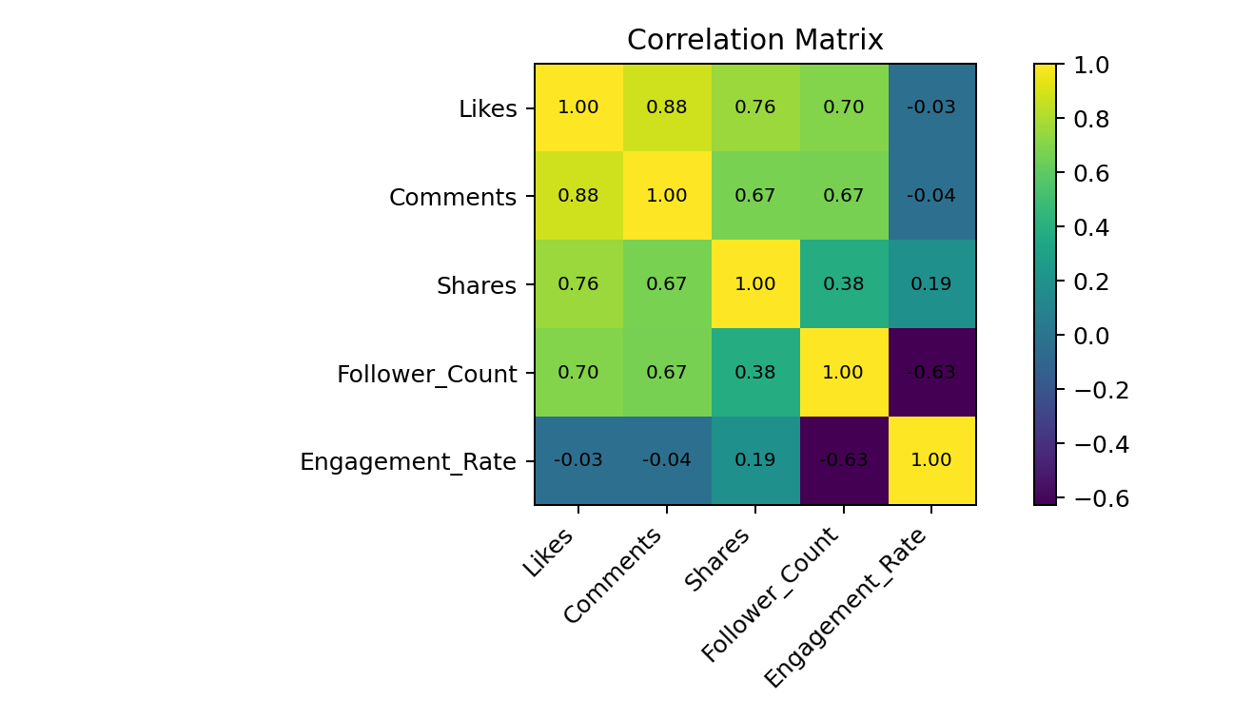
The matrix shows how strongly the engagement measures move together. Follower count is also compared with engagement rate to avoid treating audience size as the only indicator of performance.

7. Outlier Detection
The IQR rule is applied to total engagement. Values below Q1 − 1.5×IQR or above Q3 + 1.5×IQR are treated as potential outliers.
q1 = posts["Engagement"].quantile(0.25)
q3 = posts["Engagement"].quantile(0.75)
iqr = q3 - q1
lower = q1 - 1.5 * iqr
upper = q3 + 1.5 * iqr
outliers = posts[
(posts["Engagement"] < lower) |
(posts["Engagement"] > upper)
]
Post_ID | Content_Type | Hashtag | Likes | Comments | Shares | Engagement
P009 | Video | #DataScience | 259 | 27 | 12 | 298
P017 | Text | #Campus | 25 | 2 | 1 | 28
P033 | Image | #DataScience | 201 | 23 | 9 | 233

The IQR method identifies 3 potential outlier post(s). These posts should be checked for viral content, unusual timing or unusually weak reach.
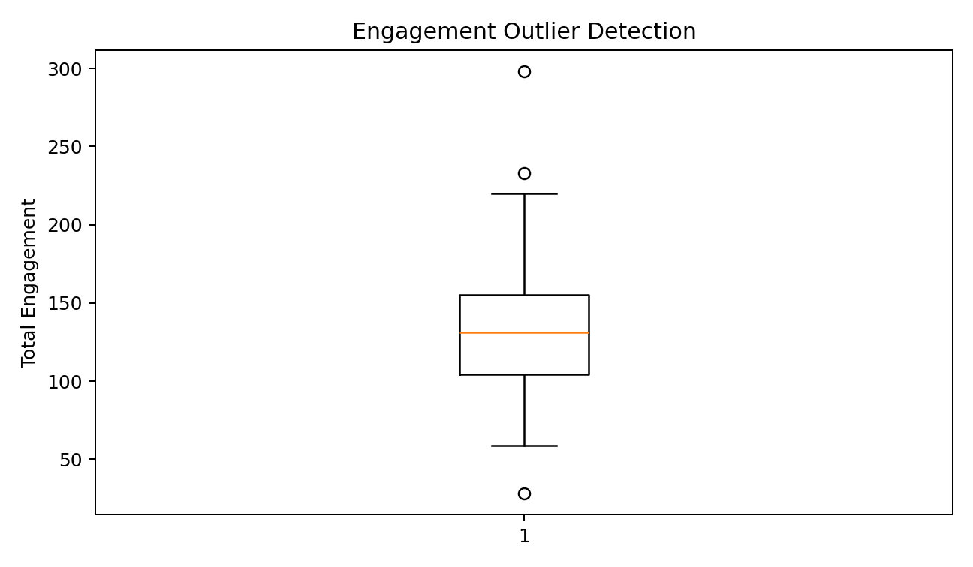

8. Time-Based Analysis
Posting hour and month are extracted from the timestamp to compare audience response across time.
posts["Post_Time"] = pd.to_datetime(posts["Post_Time"])
posts["Posting_Hour"] = posts["Post_Time"].dt.hour
posts["Month"] = posts["Post_Time"].dt.to_period("M").astype(str)
hourly = posts.groupby("Posting_Hour")["Engagement"].mean()
monthly = posts.groupby("Month")["Engagement"].sum()
print(hourly)
print(monthly)

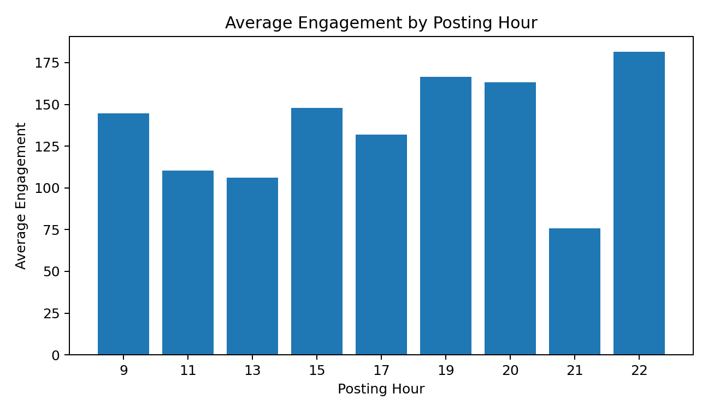
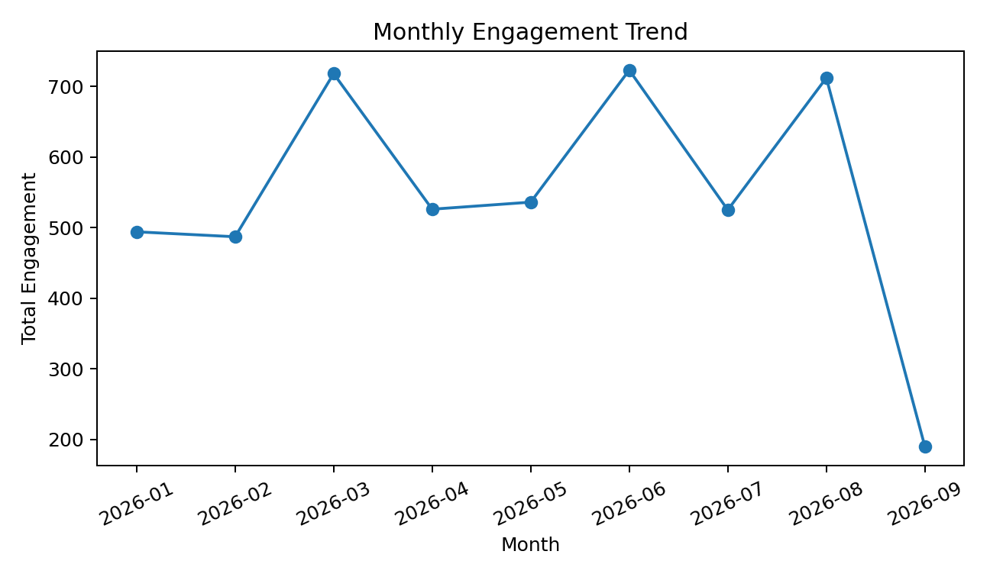
The hourly chart identifies the stronger posting windows in the sample, while the monthly trend shows how total interaction changes over the observation period.

9. Visualization
Three direct comparison charts are included below. Together with the correlation matrix and outlier plot, they provide a compact visual summary of the case study.
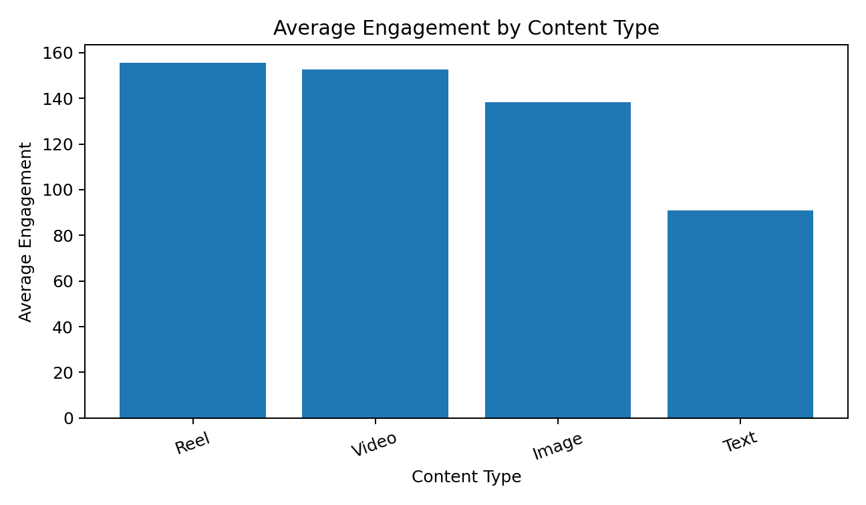
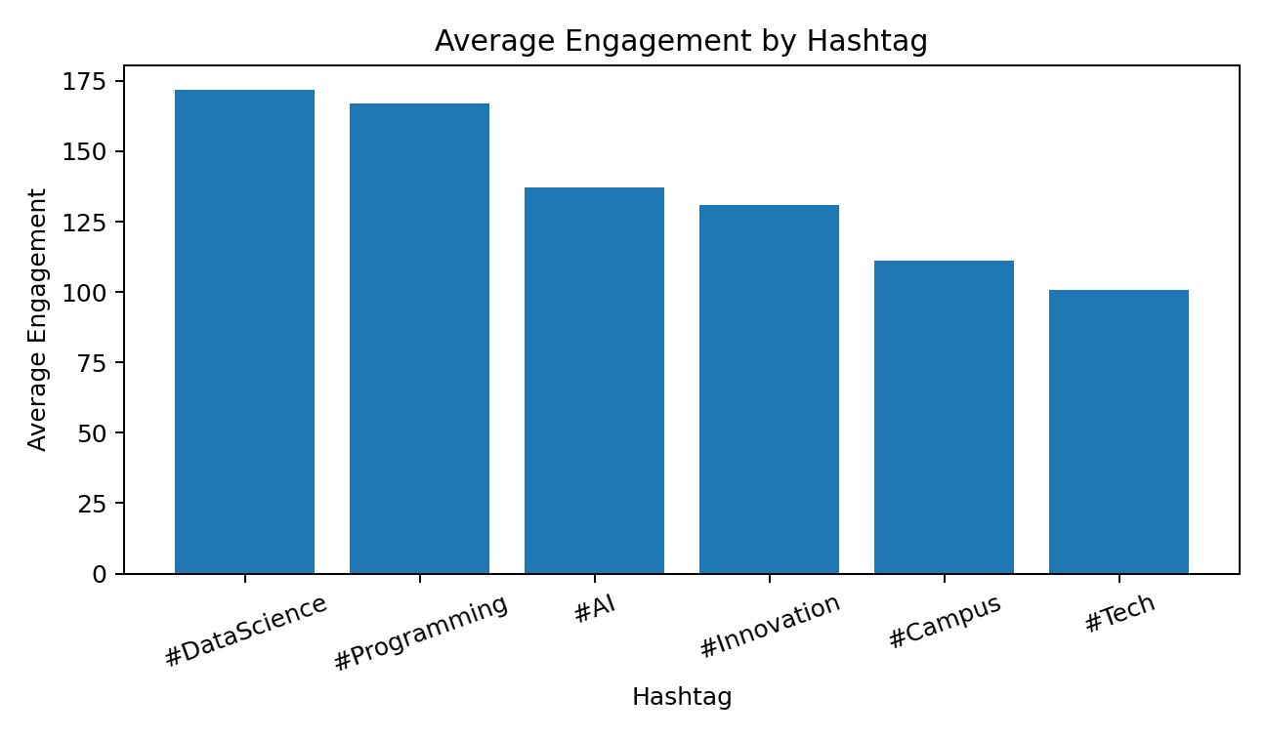
For an interactive dashboard, these same fields can be placed into Power BI or Tableau with filters for location, content type, hashtag, month and user segment. Useful KPI cards are Total Posts, Total Engagement, Average Engagement Rate and High-Engagement Users.

10. Key Findings, Conclusion & Recommendations
- Reel has the highest average engagement in the sample, at approximately 155.6 interactions per post.
- #DataScience records the highest average engagement among the sampled hashtags.
- The strongest observed posting hour is 22:00, with approximately 181.5 average interactions.
- 2026-06 has the highest total engagement in the observation period.
- The correlation between follower count and engagement rate is -0.63; therefore, follower count should not be used as the sole measure of content quality.

Recommendations
- Prioritize the strongest-performing content format while continuing controlled testing of other formats.
- Use high-performing hashtags as part of a measured hashtag mix and compare their results over future posts.
- Schedule important content around the stronger observed engagement windows and confirm the pattern using a larger dataset.
- Review outlier posts separately to identify repeatable factors behind unusually high or low engagement.
- Track engagement rate and interaction quality in addition to follower count so smaller but highly active audiences are not overlooked.

Conclusion
The joined social media dataset provides a clear basis for studying user engagement, content popularity, hashtags and posting behaviour. Grouping and segmentation identify stronger performers, correlation measures relationships between variables, IQR detects unusual engagement values, and time-based analysis reveals useful posting patterns. The combined results support data-driven decisions about content planning and audience engagement.

Full Actual Code that I Worked
The following compact script contains the main operations used in the case study and can be adapted directly to the actual CSV files.
import pandas as pd
import matplotlib.pyplot as plt
# Import
users = pd.read_csv("User.csv")
posts = pd.read_csv("Post.csv")
hashtags = pd.read_csv("Hashtag.csv")
likes = pd.read_csv("Like.csv")
comments = pd.read_csv("Comment.csv")
shares = pd.read_csv("Share.csv")
# Join
posts = posts.merge(users, on="User_ID", how="left")
posts = posts.merge(
hashtags[["Hashtag", "Hashtag_ID", "Category"]],
on="Hashtag", how="left"
)
engagement = (
likes.merge(comments, on="Post_ID", how="outer")
.merge(shares, on="Post_ID", how="outer")
)
posts = posts.merge(engagement, on="Post_ID", how="left")
# Engagement
posts[["Likes", "Comments", "Shares"]] = (
posts[["Likes", "Comments", "Shares"]].fillna(0)
)
posts["Engagement"] = (
posts["Likes"] + posts["Comments"] + posts["Shares"]
)
posts["Engagement_Rate"] = (
posts["Engagement"] / posts["Follower_Count"] * 100
)
# Time features
posts["Post_Time"] = pd.to_datetime(posts["Post_Time"])
posts["Posting_Hour"] = posts["Post_Time"].dt.hour
posts["Month"] = posts["Post_Time"].dt.to_period("M").astype(str)
# Grouping
content = posts.groupby("Content_Type")["Engagement"].agg(
["count", "mean", "sum"]
).sort_values("mean", ascending=False)
hashtag = posts.groupby("Hashtag")["Engagement"].mean(
).sort_values(ascending=False)
# Segmentation
user_engagement = posts.groupby("User_ID")["Engagement"].sum()
segments = pd.qcut(
user_engagement, q=3,
labels=["Low", "Medium", "High"]
)
# Correlation
correlation = posts[
["Likes", "Comments", "Shares",
"Follower_Count", "Engagement_Rate"]
].corr()
# IQR outliers
q1 = posts["Engagement"].quantile(0.25)
q3 = posts["Engagement"].quantile(0.75)
iqr = q3 - q1
outliers = posts[
(posts["Engagement"] < q1 - 1.5 * iqr) |
(posts["Engagement"] > q3 + 1.5 * iqr)
]
# Time analysis
hourly = posts.groupby("Posting_Hour")["Engagement"].mean()
monthly = posts.groupby("Month")["Engagement"].sum()
# Visualizations
content.plot(kind="bar", y="mean", legend=False)
plt.title("Average Engagement by Content Type")
plt.ylabel("Average Engagement")
plt.tight_layout()
plt.show()
hourly.plot(kind="bar")
plt.title("Average Engagement by Posting Hour")
plt.ylabel("Average Engagement")
plt.tight_layout()
plt.show()
monthly.plot(marker="o")
plt.title("Monthly Engagement Trend")
plt.ylabel("Total Engagement")
plt.tight_layout()
plt.show()

